

**Lakeside Primary School**

Leyland Road, Glascote, Tamworth, Staffs, B77 2SA

Tel: **01827 213990**

email:[**office@lakeside.staffs.sch.uk**](mailto:office@lakeside.staffs.sch.uk)

lakeside_sch

**Headteacher:** Mr N Probert

**Deputy Headteacher:** Mrs V Gardner

Friday, 24 May 2024

**General Election - Thursday 4th July 2024**

Dear Parents/Carers,

As you will probably be aware, this week, the Prime Minister announced that there will be a General Election on Thursday 4th July 2024. As a result of this, **school will be closed to all pupils for this day**. We are expecting a higher turnout of voters than at the local elections and with this amount of the public visiting the school site, the health and safety of the pupils is the primary factor for making this decision. Unfortunately, the law states that ‘Returning Officer has a right by law to make use of any school premises for the purpose of an election/referendum.’ Therefore, I am unable to refuse the request when it was made yesterday.

In order to minimise the amount of disruption this will cause, teachers will be setting learning virtually and pupils will be expected to complete these tasks during the day. We shall ensure that they have the necessary login details to complete their learning at home. However, if you have difficulties accessing a digital device to complete the learning, please speak to your child’s teacher so we can make alternative arrangements.

Teachers will be available throughout the day to respond to questions children may have should they need support.

As ever, if you have any questions, please do not hesitate in getting in touch.

Yours sincerely

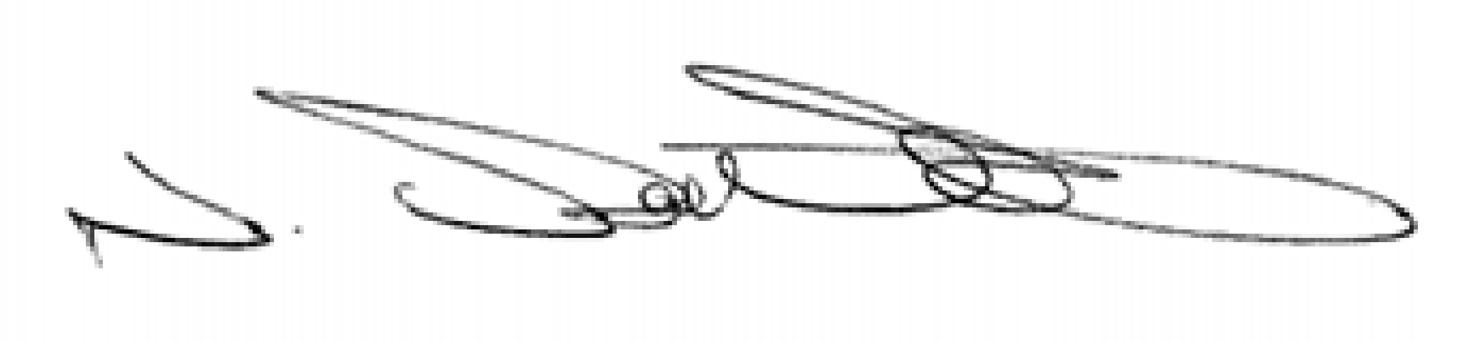

**Mr N. Probert**

**(Headteacher)**